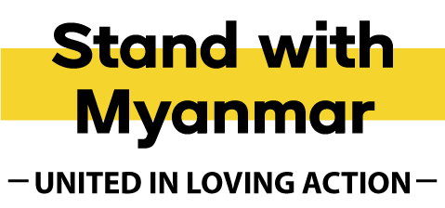

We recommend reading these notes before using the provided template on page two to email or post your letter.

- Simply use the letter template provided on the next page, adding your details and your local member’s details (as per the guide linked below) in the areas marked in red font.
- Find out who your local MP is and how best to address them.
- A full list of Ministers, Members of Parliament, Senators and Electorates along with their email address details can be located here: www.aph.gov.au/Senators_and_Members
- A guide on how to address Senators and Members, along with a link to download mail addresses can be located here: https://www.aph.gov.au/Senators_and_Members/Contacting_Senators_and_Members
- You're welcome to personalise the letter based on your experience, but please do not alter the three asks, as they were developed in consultation with Burmese church leaders in Australia and humanitarian organisations working in Myanmar.
- Email, post or hand deliver the letter to your local MP’s contact details.

Thank you for joining us in speaking up for change for the people of Myanmar.

Dear Minister [Last Name],
As a member of your electorate, I’m deeply concerned about the worsening crisis in Myanmar—especially with the recent withdrawal of critical aid services for displaced communities suffering violence at the hands of the military junta.
Already, the withdrawal of USAID and other major donors has been detrimental to people living in nine displacement camps along the Myanmar-Thailand border. Health clinics have closed, and organisations providing food have been forced to reduce their rations to 80 per cent of families in these camps. This leaves around 100,000 Myanmar refugees without enough food or access to medical care.
The Australian Baptist community feels this tragedy acutely, with more than 27,000 people from Myanmar (including 10,000 Baptist Christians) currently calling our country home. With loved ones back in Myanmar still in peril, their lived experience is a constant reminder of the urgency and importance of Australia’s role in standing with Myanmar.
I appreciate the important steps this Government has already taken to address injustice in Myanmar by applying sanctions on the junta. These meaningful actions have not gone unnoticed, nor has the emergency humanitarian funding released after the recent earthquake in the Mandalay areas.
However, with the scale of suffering continuing to escalate, we are asking the Australian Government to urgently:
- Deliver a $110M emergency package for Myanmar, including:
  - $70M to restore basic food aid and re-open health clinics for more than a million displaced people in refugee camps in bordering countries
  - Inside Myanmar: $40M to stabilise food and health services at high risk of closure further hit by donor country cuts, April’s earthquake, and July’s floods.
- Increase the number of offshore humanitarian refugee visas granted to Myanmar nationals to 5,000, so separated families can reunite.
- Increase diplomatic pressure on and pursue further financial actions with the capacity to isolate the military junta, reducing access to supply chains that fund their operations, and allowing humanitarian aid to be accessed by those most in need within Myanmar.
Thank you for your ongoing leadership and commitment to justice for the people of Myanmar.
Yours sincerely,
[Your Name]

